
Year 8 Science 2015

Energy Topic Test - Modified

  - Name ____________________________
  - Teacher ____________________________
  - Score _____ / 36 _____ %

 | Which of the following is a form of kinetic energy?  - Motion  - Chemical  - Elastic  - Nuclear |  | 1
 | The energy we receive from the sun includes:  - electrical and sound energy.  - heat and nuclear energy.  - electrical and light energy.  - heat and light energy. |  | 1
 | The petrol needed to make a car move is a form of:  - kinetic energy.  - chemical potential energy.  - elastic potential energy.  - gravitational potential energy.  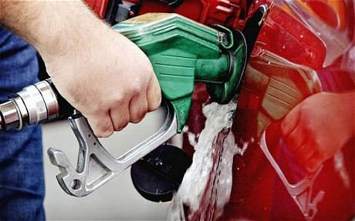 |  | 1
 | When a bicycle skids to a stop, its kinetic energy is mostly transformed into:  - heat and sound.  - potential energy.  - sound energy.  - heat and light.   |  | 1
 | When you place a metal saucepan on the heating element of a stove, heat is transferred to the saucepan by:  - reflection.  - convection.  - conduction.  - radiation.  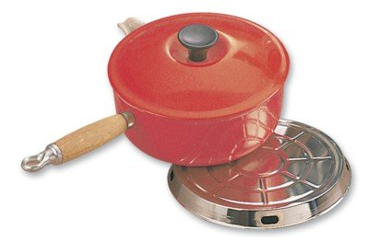 |  | 1
 | Which two types of heat transfer listed below are reduced by placing insulation in the ceiling of a house?  - Conduction  - Convection  - Radiation |  | 1
 | When you are active in cool weather, heat is transferred from your body by:  - radiation.  - convection.  - conduction.  - evaporation.  - all of the above. |  | 1
 | Which of the following can be described as being luminous?  - Streetlights (turned on)  - A road sign  - The moon  - Water  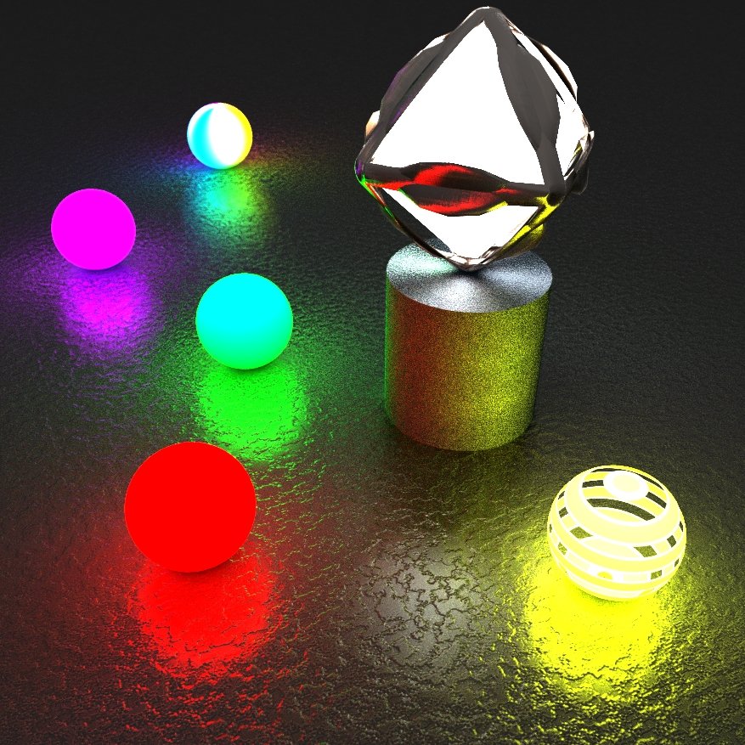 |  | 1
 | Name the odd one out.  - Guitar 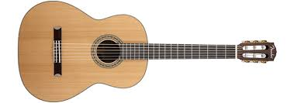  - Clarinet  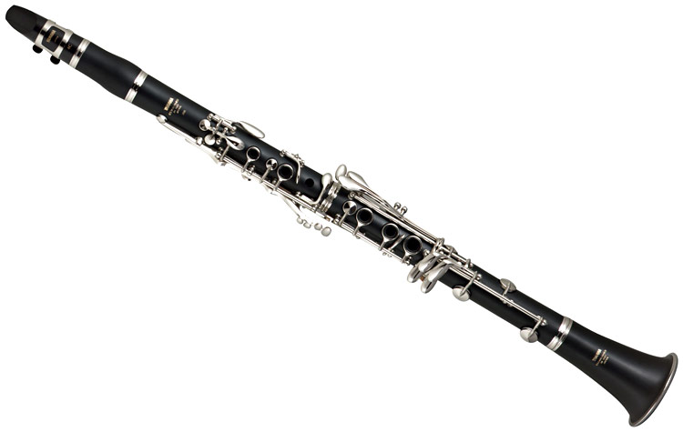  - Saxophone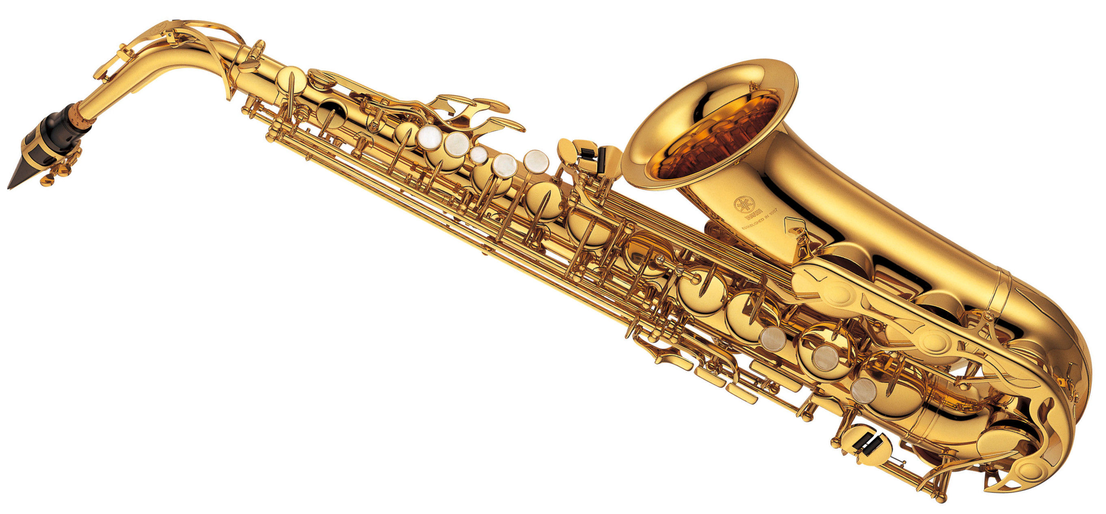  - Flute  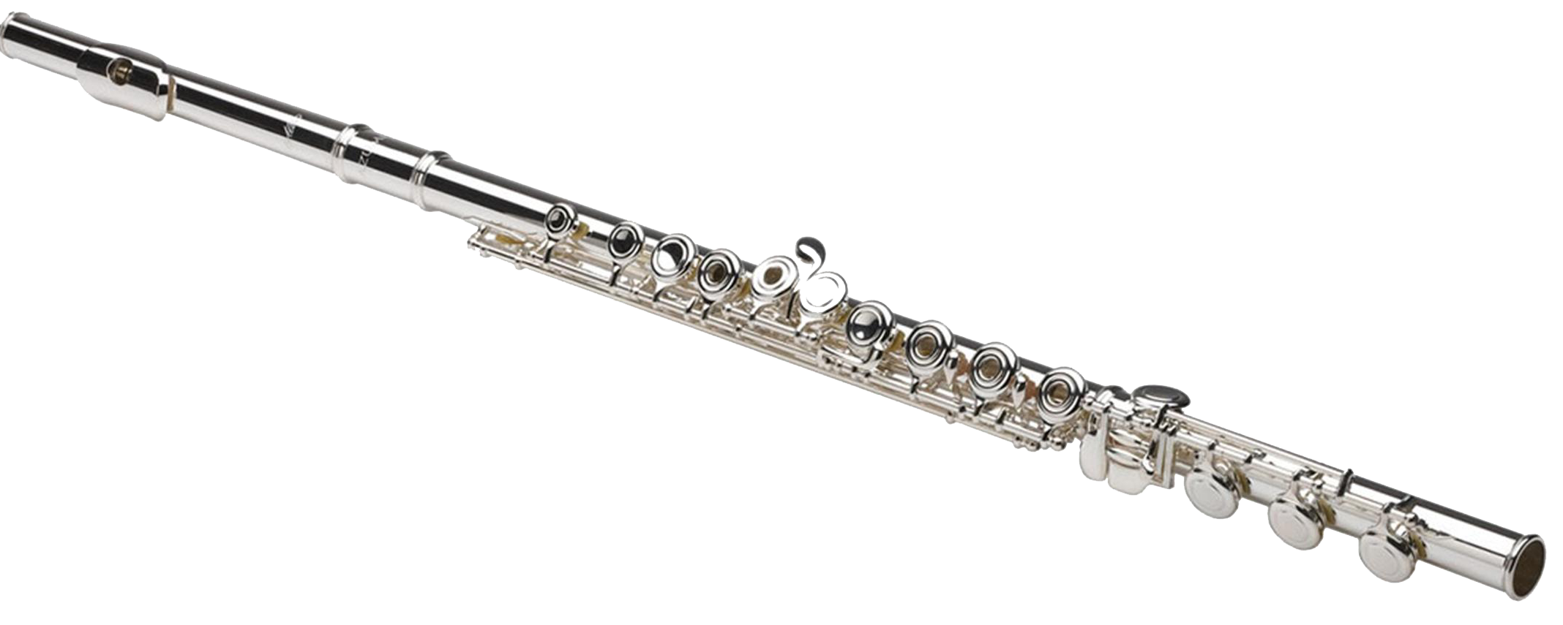 |  | 1
 | In the burning of fireworks during New Year displays, chemical potential energy is converted into:  - heat, light and sound energy.  - light and sound energy.  - sound and heat energy. |  | 1
 | True or false:  - Energy can be transferred to another object.  - Energy can be stored.  - Energy can be created as well as destroyed. |  | 3
 | Four different types of light globes were tested for their efficiency. The results are in the table below.  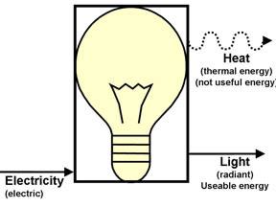  Globe number Heat output Light output  1 85% 15%  2 90% 10%  3 50% 50%  4 30% 70%  - What is ‘efficiency’? Use the words ‘input’, ‘output’ and ‘useful’ to help you explain.  - Which globe is the most energy efficient? Explain your answer using data from the table.  - What was the energy source (original form of the energy) that was converted to produce light and heat from the globe?  - Why is it better to have energy-efficient light globes? |  | 6
 | Name a something that changes:  - chemical energy into kinetic energy  - chemical energy into light energy  For example, a GAS HEATER turns chemical energy (from the gas) into heat energy.  Other kinds of chemical energy include food, petrol, batteries and chemicals in the lab. |  | 2
 | 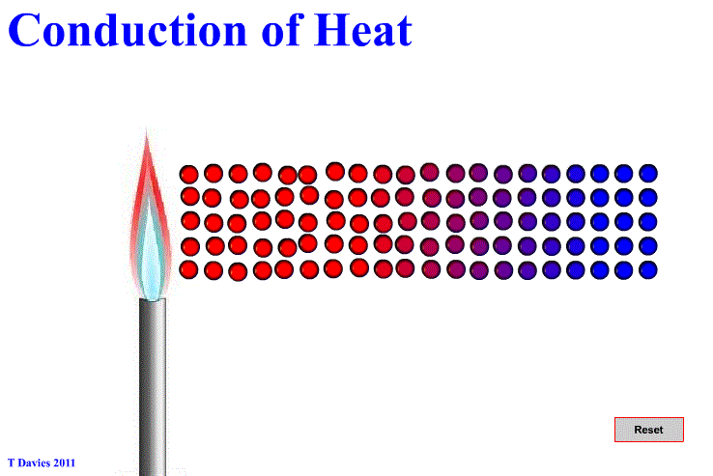  (a) Identify materials that are good heat conductors.  (b) What name is given to materials that are poor heat conductors? |  | 2
 | List one place where heat is lost from a home during winter.  State how the heat is transferred and how heat loss may be reduced.  Heat is lost from a home through the  _____________________  It is transferred by (circle one)  Conduction Convection Radiation  You could stop this happening by…  ____________________________  ____________________________ |  | 6
 | Draw a diagram to show an energy transformation (energy changing from one form to another) that you know about.  Here are some examples.  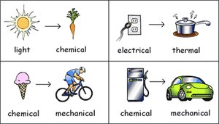 |  | 4
 | Is the moon luminous (produces its own light) or non-luminous (reflects the light from something else)? Give a reason for your answer. |  | 2
 | Why do you always hear thunder after you see the lightning that caused it? |  | 1

